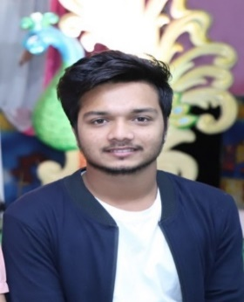**Ritik Vichave**

9834296573/8308344623 | [vichaveritik@gmail.com](mailto:vichaveritik@gmail.com)

At post Jalgoan (MH) 425508

Linkedin_url = [linkedin.com/in/ritik-vichave-2ab246200](https://www.linkedin.com/in/ritik-vichave-2ab246200)

**React Stack Developer**

**OBJECTIVE:-**

A computer science graduate want to build/develop his career in react developer in an origination of repute.

**Web development | HTML | CSS | JavaScript | React |Redux** .

**EDUCATION:-**

* Master in computer application (M.C.A): - Pursing (1st year).
* Bachelor in computer science (Bsc.cs): - Passed (80.93%).

**ACHIEVEMENT:-**

* State level hockey champion.

**SPECIAL SKILLS:-**

1. **Technical skills**: - React , javascript etc.
2. **Soft Skills**: - Good listener, team player, motivated & Good commination skills.

**INTERNSHIPS:-**

* Organization name: solutions Peer services pune (Experince :6 month).
* Organization name: Skill hub IT solutions Aurangbad (Experince : 1 year, fullstack intern).
* Organization name : CogniAble Gurgoan Currenly working in a product base company (Reactjs intern ,Experince : 4 month).
* Total 1 year 10 month of experience.

**Project Title –** Web Page Designing.

1. Used key frames to show animations on designed webpage.
2. Designed a responsive and intuitive design using HTML code.
3. Made E-commerce website.
4. Made a portfolio of modal.

**Technologies Used –** HTML | CSS | SASS| Bootstrap| JavaScript. | Reactjs | Nodejs | MONGODB | Express

**PERSONAL DETAIL:-**

* Date of birth = 24/02/200.
* Marital status = Unmarried.
* Language = Marathi, English, Hindi.

**HOBBIES:-**

* Reading books, playing football, gym etc.